**Library Management System - Book Management API**

**Overview:**

The Book Management API of the Library Management System provides endpoints to perform CRUD (Create, Read, Update, Delete) operations on books stored in the library database.

**Endpoints:**

**1. Retrieve All Books**

**Endpoint: GET /getAllBooks**

**Description: Retrieves all books available in the library.**

**Response:**

**Status Code: 200 OK on success, 400 Bad Request on failure.**

**Body:** **{**

**"data": [List of Book Objects],**

**"message": "X record(s) fetched.",**

**"errorMessages": [List of error messages]**

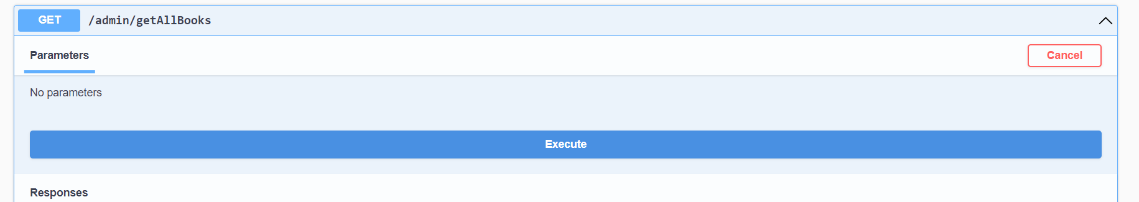**}**

**2. Retrieve Book by ID**

**Endpoint: GET /getBookById/{bookId}**

**Description: Retrieves a book by its unique identifier.**

**Parameters:**

**bookId: ID of the book to retrieve.**

**Response:**

**Status Code: 200 OK on success, 400 Bad Request on failure.**

**Body:** **{**

**"data": [Book Object],**

**"message": "1 record(s) fetched.",**

**"errorMessages": [List of error messages]**

**}**

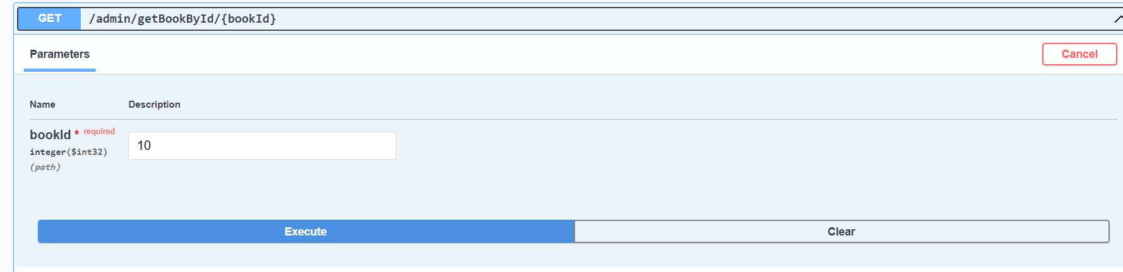

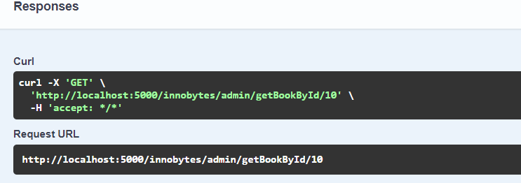

**Add New Book**

* **Endpoint: POST /addBooks**
* **Description: Adds a new book to the library.**
* **Request Body:** **{**
* **"title": "Book Title",**
* **"author": "Author Name",**
* **"isbn": "ISBN Number",**
* **...**
* **}**
* **Response:**
* **Status Code: 200 OK on success, 400 Bad Request on failure.**
* **Body:** **Response:**
* **Status Code: 200 OK on success, 400 Bad Request on failure.**
* **Body**
* **Response:**
* **Status Code: 200 OK on success, 400 Bad Request on failure.**
* **Body:** **{**
* **"data": [Added Book Object],**
* **"message": "1 record(s) added.",**
* **"errorMessages": [List of error messages]**
* **}**

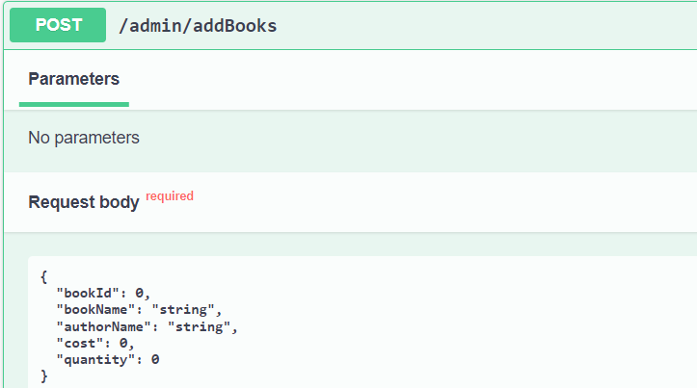

**Update Existing Book**

**Endpoint: POST /updateBooks**

**Description: Updates information of an existing book in the library.**

**Request Body:** **{**

**"id": 1,**

**"title": "Updated Title",**

**"author": "Updated Author",**

**"isbn": "Updated ISBN",**

**...**

**}**

**Response:**

**Status Code: 200 OK on success, 400 Bad Request on failure.**

**Body:** **{**

**"data": [Updated Book Object],**

**"message": "1 record(s) updated.",**

**"errorMessages": [List of error messages]**

**}**

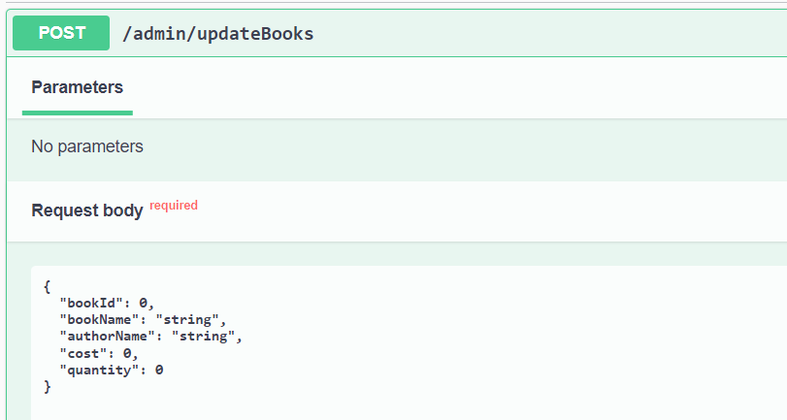

**Steps to run this project:-**

1. **Right click main project file(LibrarymanagementApplication.java)**
2. **Right click on that file and Go to run as -> Run configurations…**
3. 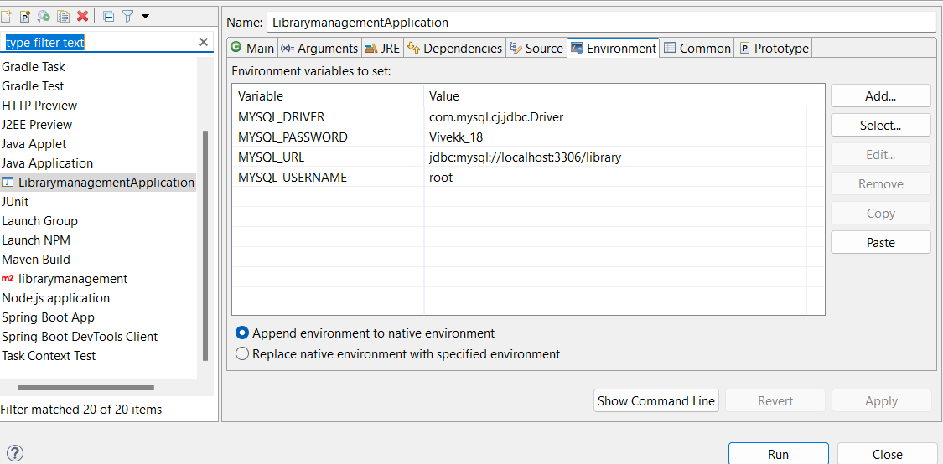
4. **Put the environment values according to your database and click on run.**

**Swagger link :- http://localhost:5000/innobytes/swagger-ui/index.html#/**

**Error Handling:**

**The API handles exceptions and returns appropriate error messages along with the status code 400 Bad Request.**

**Error messages are returned in the response body under the errorMessages field.**

**Security:**

**Ensure proper authentication and authorization mechanisms are implemented to protect sensitive operations like adding or updating books.**

**Usage:**

**Integrate this API with the front-end or other systems to manage library books efficiently.**

**This documentation provides an overview of the Book Management API in the Library Management System, including endpoints, request/response formats, error handling, security considerations, and usage guidelines.**